COASTAL PLANTING - NOTES from MASTERCLASS

The Garden Designer’s Guide to Coastal Planting by Janine Pattison MSGD MBALI

The Challenge
The Coastal Environment - coping with the elements
The challenges facing the gardener when designing the planting for a coastal garden are many and should not be underestimated. The harsh effects of wind, salt and sand combine to create very tough conditions for the plants and it is vital to work with these limitations in mind as it is more likely to be successful than trying to change them. There are positives around gardening next to the sea and these will often be the reduced chance of frost, generally warmer temperatures than inland and higher levels of sunshine.

Wind
Wind is one of the most destructive elements to a coastal garden. The site may have been chosen because of its open nature and there is usually pressure to maintain this so as not to interrupt the views. However the relentless nature of wind on the coast will have a marked impact on the plants. Leaves may get shredded, branches broken, even whole plants uprooted. Soil can be blown away, exposing roots and causing plants to suffer and even die. Plants can often be seen which have been ‘wind pruned’ by the prevailing wind. The wind has suppressed growth on the windward side of the plant and caused an uneven shape.

Wind can strip plants of moisture causing drought stress through desiccation. If the plant is losing more moisture from its leaves than it can absorb via its roots the plant will wilt. Unless the drought stress is remedied by watering, the plant will become vulnerable to pests and diseases or may simply die. Dryness at the root zone is a common problem for coastal plants as the soil is often sandy and free draining and the plant cannot keep up with demand for moisture by its leaves.
This condition can arise at any time of the year as even in winter when the plant is dormant it may become desiccated. These plants appear to be alive in winter but fail to emerge in the spring.
Evergreen shrubs seem to be most vulnerable to this situation.

Sand
Sandy soil is typical on the coast and it presents advantages and disadvantages to the gardener. Sand is grainy and has large pockets of air between the particles. This means that it is difficult to compact and provides a good medium for plant root penetration. Sandy soils warm up quickly in the spring and remain workable for a large part of the year. Water can percolate through a sandy soil very easily and quickly and it rarely becomes waterlogged. This can be considered an asset as few plants can cope with being sat in brine-y soil for any length of time.

Sandy soils give up surface water very quickly to evaporation and once in the soil, water drains through and away often before plants have been able to intercept it. The lack of organic matter in the sandy soil means that it contains few nutrients; if the soil also contains a large amount of crushed seashells, the situation is even worse. Shells are made of calcium - basically pure lime in gardening terms- and in large concentrations, lime increases the pH (more alkaline) and locks up the few available nutrients, thereby preventing their absorption by plants.

Salt
In the air, salt burns sensitive leaves; in the soil, it completes for available moisture; and in the water, it is toxic to the tissues of all but the most specialised plants. Seawater is around 3% salt and a solution of half that is fatal to most ordinary plants. Salt is not good for plants.

Sea breezes are laden with salt and once they have crossed the beach continue inland for a fair way, often for 300+ metres, extending the seaside zone considerably. Gardens set back many metres from the beach are subject to significantly higher concentrations of airborne salt. Spring storms are the most destructive, churning up seawater into the onshore wind which will burn the tender new leaves of all but the toughest seaside plants.

The bracing sea air is not all bad though. Salt does have natural antiseptic qualities and it is believed that the salt-laden air found on the coast can have a positive effect on reducing the instances of fungal growth on plants.

Weather
Climatic conditions vary around the world, yet coastal communities share a number of similarities in their weather. Clear days are extremely bright, as light comes from almost every direction - reflected by sand, sea, water, and an unobstructed sky. The resulting glare is intense, particularly when combined with higher temperatures and the drying winds.

These effects are often amplified by the limited planting cover found at the seaside. The open topography is exaggerated as there are few plants to contribute any shady relief.

The Coastal Environment - the positives
There are, of course many benefits of gardening on the coast and the good air circulation, lower levels of pollution, increased hours of sunshine and absence of frost are considerable advantages.

SOLUTIONS

Shelter
Permanent artificial shelter Walls and banks
Walls and banks make solid, impermeable barriers which are likely to be permanent. They are usually used on a boundary and usually require the neighbour’s agreement. They provide valuable protection and shelter to plants particularly while they are getting established.
These solid barriers can, however, create some problems of their own. Many plants will not be able to grow above the height of the top of the wall as the force of the wind literally ‘burns off’ the new growth.
A solid barrier deflects wind and, when this happens, the speed increases over the top and at the ends of the barrier. This effect can be noticed between two buildings where the wind has been deflected and its speed has increased dramatically as it passes between the houses creating an uncomfortable ‘wind tunnel’ effect. Immediately behind the barrier will be an area of relative calm, however further away the wind will drive downwards to create an area of strong turbulence which will cause damage to plants. The zone of calm and the area of turbulence will depend on the height of the barrier and the strength of the wind.

Temporary artificial shelter Fences, netting, mesh etc.
All fencing in a coastal environment can be considered temporary. The harsh environment will usually shorten the life of a fence by several years compared to one further inland. A solid fence will catch the full force of the wind and act like a sail. Even stout posts, well concreted in will eventually fail. A better solution is often to use a more permeable fencing option - something which allows some of the wind through it but at reduced speeds (50%). Some wind is deflected over the top and to the side, so there may still be some turbulence but vastly reduced from a solid barrier.

A timber fence made of slats with gaps between can be very effective. The slats can be vertical or horizontal but it has been found that the optimum permeability is around 40 to 50%. Other temporary fencing which should last long enough for plants to get established include plastic mesh fencing. This can be purchased in a dark green colour and will all but disappear once the plants have been installed. It can usually be removed after 2 or 3 years.

Soil Preparation
Like all garden plants everywhere, seaside plants require decent quality soil to thrive. The natural ground is likely to be sandy and may be rocky or stony and will need to be improved before it becomes suitable for the new plants. Good garden soil needs to contain moisture, nutrients and air spaces to allow gaseous exchange to take place. A good volume of organic matter is vital for this to happen. Seaside soils tend to be extremely low in organic matter and so can be lacking in essential nutrients required for plant growth as well as too freely drained. Unimproved seaside soil can cause plants to be stunted, have yellowing foliage and be vulnerable to disease. Generous addition of bulky organic matter to the soil at the time of preparation before planting will be rewarded with healthier plants more able to cope with the conditions and fight off disease.
Every garden should ideally have a compost bin to receive lawn clippings, kitchen waste and prunings. Once rotted this valuable material can be reincorporated into the garden as a mulch or soil improver for future plantings.

Staking
Trees
Newly planted trees will definitely require staking for the first few years no matter what size they are when planted. The stake should be in proportion to the tree and the tie should be adjustable so that it can be loosened as the tree grows. Once the tree has become established then the tree stake can be dispensed with (usually after 2-3 growing seasons) though the tie will require annual inspections to adjust against growth. It is vital that the stake is driven into the planting hole before the tree is planted so that the tree's roots are not damaged.

Shrubs
It would not normally ever be necessary to stake a shrub. However if the shrub is very large or has been transplanted from elsewhere on the site then a stout stake and tie will help immobilise the plant while the roots get established. The shrub may otherwise be continually blown over and not be able to send its roots into the surrounding soil.

Perennials
The careful use of staking can greatly improve the appearance of taller or lax stemmed plants especially perennials which are vulnerable to damage by the wind. Staking can take many forms, but the trick is to make the staking as unobtrusive as possible. This is mainly done by staking early, well before the plant needs it. The stakes will be visible for several weeks while the plants grow up through them. Once the plants have reached any size the mechanics of the staking will become invisible.

There are many options available for staking plants; from bought systems in metal to homemade supports made of bamboo canes and string, hazel sticks or willow wands twisted and bent over. A lot depends on budget and time available to create what will be adequate for the job.

What makes a good coastal plant?
For plants to survive in a coastal garden they must be able to tolerate drought, heat, extreme wind, salt and sand. Not surprisingly given the extreme environment they grow in, many seaside plants share a number of similarities. This phenomenon is called parallel evolution; basically in response to similar conditions plants take on similar characteristics. These similarities are a huge help to the coastal planting designer when selecting plants for a seaside garden.

Many of the plants that succeed in coastal sites have special adaptations that enable them to shrug off the worst effects of wind and salt spray. Often these plants have tough, leathery leaves while others have leaves with a protective covering of fine hairs, which limits salt damage and helps conserve moisture.

Many seaside plants have small leaves, because small leaves allow wind to pass through easily, without tearing or ripping the leaf. A reduced leaf surface is an efficient adaptation to seaside conditions, as it minimises water loss through evapotranspiration and vulnerability to damage by

salt spray. Evergreen needles are also specially adapted to minimise moisture loss. They cope well in wind too, even a winter storm is likely to pass through the fine foliage causing minimal damage.

There are other leaf adaptations which help reduce a plants vulnerability to salt damage. Tough, glossy foliage has a waxy surface or cuticle which acts as a protective layer which is resistant to salt and the drying effect of strong wind.
Leaves covered in tiny hairs make them feel furry and this is another protective device as the hairs trap the salt and sand particles and keep them away from the tender surface of the leaf. Furry leaves are often silver or grey and this colouring is another successful adaptation of some seaside plants like Artemisia. The leaves are able to reflect some sunlight and so help the plant to avoid becoming overheated in the higher temperatures and light levels of the coast.

Some plants have evolved stems or leaves which have a scaly nature. This characteristic is a direct response to reduce moisture loss and reduce the exposure to salt and sand. Ericas and Callunas have developed this adaptation and can be seen growing in pure sand very close to the sea.

Coastal conditions can rather desert-like with lack of moisture and high light levels meaning drought stress for our plants. Succulent plants like sedums have evolved thick fleshy leaves which can hold reserves of moisture to see the plant through periods of water shortage.

All successful seaside plants tend to have extensive root systems which are able to delve deep into the soil, searching for moisture, and many have single taproots that reach down towards the cooler soil and more available groundwater. Planting these plants quite small will allow them to establish much better than transplanting a larger specimen.
Encouraging strong root growth is vital to secure the plant in the ground so that is doesn't get blown over or even out of the ground. It will also help prevent sand and soil being blown away by strong winds or eroded by heavy rainfall.

Habit
Many seaside shrubs develop more branches than their inland cousins. This characteristic appears to be a reaction to the conditions of wind, lower fertility and lack of moisture. The costal conditions produce naturally smaller and denser plants, however they can often be more floriferous than their more sheltered cousins and require less pruning to keep within allocated bounds.

Names and Latin
A plants's botanical name can be an indicator that it might be a suitable coastal plant. The second part of the botanical name often describes a characteristic of the plant, this could be where it comes from, what it looks like or what conditions it enjoys. For example:

Maritima, maritimus, marinus - likely to thrive along the coast
Atlantica - of the Atlantic Pacifica - of the Pacific Corsica - of the Mediterranean Cretica - of the Mediterranean
Arenarius - found growing in sand
Palustrus - found growing in marshes and wetland
Hali - meaning to do with salt
Littoralis - of the seaside

Examples: Rosmarinus, Eryngium maritime, Cedrus atlantica 'Glauca', Griselina littoralis

The plants listed below are known from our experience to tolerate the coastal conditions, there are a number of published lists which are also available and local conditions may suit some plants more than others.

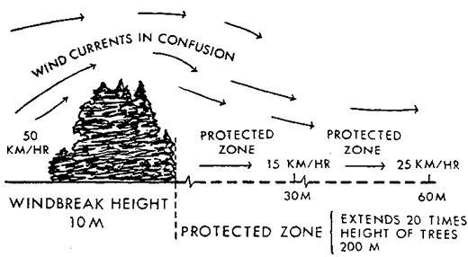
Trees
Trees to create a shelter belt
If you have the space there is no better way to deal with the wind than to plant trees which have the ability to reach a good size in spite of the harsh conditions found on the coast. Planting these trees is a long-term investment but in those gardens which already enjoy the benefit of large trees on the windward side the improvement in growing conditions for other plants is huge. The aim is to
make a semi-permeable barrier which lets some wind through (40-50%) but deflects wind over the sheltered zone. There is not a great deal of choice when it comes to trees to form shelter belts by the sea. The most effective are the evergreen types, which will give protection all the year round, but there are also some very good deciduous trees worth considering. These will be at their most efficient as wind filters when in full leaf, but in winter they can still reduce wind speed on the leeward side significantly. Plant small to acclimatize them to the conditions.

The best evergreen trees for shelter belt planting are:
- Pinus radiata (Monterey Pine) lime hater ①
- Cupressus macrocarpa ①
- Quercus ilex ①
- Pinus nigra ①

These large trees will reach significant heights and by careful removal of lower branches as they grow, can open up previously blocked views. This ‘crown lifting’ will need permission from the local authority if the tree carries a protection order or the site is a Conservation Area or National Park etc. Always satisfy yourself that correct permissions have been granted before any work to trees is carried out.

There are a few deciduous trees which will grow here but which are likely suffer from various unsightly effects as a result of the wind and salt spray from winter and spring storms.
- Acer pseudoplatanus ① (Sycamore) will survive but is likely to have newly emerging leaves burnt by the wind and salt. They are also prone to growing into odd shapes as a result of trying to avoid the persistent wind.
- Acer platanoides ② (Norway Maple) will also cope with such exposed locations and is likely to suffer similar leaf damage as the sycamore. There are many cultivars available with foliage ranging from golden yellow to darkest purple.
- Populus alba ① (White Poplar) is a large, fast growing tree which thrives in a coastal location. It seems to shrug off salt spray and can be a good choice when speed of growth is important.
Within these notes we have ranked plants as suitable for:
① first line of defence (i.e. tolerant of full exposure to salt laden winds),
② second row (tolerant of exposure slightly back from the edge but in the open)
③ third row (where there is some protection from direct sea wind)
④ fourth row (suitable when a windbreak has been established)

Trees as windbreaks
There are many trees which will thrive inside the shelter belt perhaps with the protection of large shrubs around them as windbreaks. Again the evergreen varieties will be very effective all year round but they will need to sited very carefully to avoid interrupting the view.
Best evergreen broadleaf trees are:

Acacia dealbata ③
Arbutus unedo ③
Ilex aquifolium ‘JC van Tol’ ③
Eucalyptus gunnii ①
Olea europaea ③

But there are a number of evergreens, conifers and pines which are worth considering:

Cryptomeria japonica ③ Chamaecyparis lawsoniana ② Cedrus deodara / atlantica Glauca ④
Phillyrea latifolia ②
Picea glauca ②
Pinus pinea / P. sylvestris ②

x Cupressocyparis leylandii ② will also cope with the seaside conditions but think carefully before introducing this vigorous plant into your planting scheme. Once it is established it will require cutting twice a year to prevent it from taking off and reaching untold heights. It does
not break out from old wood if left untrimmed. Thuja plicata ① is a better option and also tolerant of seaside conditions if the brunt of the wind / salt is reduced by a first line defender.

Palm Trees The hardiest is the Trachycarpus fortunei ③ and this will cope with surprisingly harsh conditions but may suffer leaf tear. It needs to be well staked if it is planted at any great size.
Chamaerops humilis ②③ is also hardy but lower growing – up to 1.5m tall. The Torbay Palm,
Cordyline australis ①② is useful.

Other trees worth consideration of inclusion in your planting schemes include the following deciduous or semi-evergreen trees:

Castanea sativa ④
Nyssa sylvatica ④
Aesculus hippocastaneum ④
Ailanthus altissima ④ Albizia julibrissin ④ Amelanchier ③ Cratagus ②
Fagus sylvatica ③ Gleditsia triacanthos ④ Ginkgo biloba ②③
Magnolia grandiflora ④ - this is
usually better grown against a wall
Quercus cerris & robur ③
Salix – most ②③
Sorbus aria & aucuparia ②

Hedging
A single row of trees or shrubs, trimmed to a predetermined height and breadth, can make a formal hedge. A single row of trees or shrubs, or a mixture of shrubs, left untrimmed, can become an informal hedge. There are only a few shrubs which can make satisfactory formal coastal hedges but a far wider range suitable to create an informal hedge.

As with all planting, good ground preparation is the key to success. The area should be prepared by digging over to remove stones and rubble, bulky organic matter should be added liberally, perennial weeds should be removed and depending on the time of year, an organic slow-release fertiliser should added. Using young plants and giving them good care will result in good establishment at very reasonable cost. If possible install a mesh fence on the exposed side of the hedge to provide additional protection to the young plants during the establishment phase. The benefits of this temporary shelter will be quicker growth, more vertical growth and less damage from the wind and salt and sand spray. It will also discourage pedestrians from stepping over or through the new hedge and damaging it. This mesh protection can be removed after the first few years.

Formal Hedging
Griselina littoralis ① Prunus laurocerasus ③ Ilex spp. ①

Carpinus betulus ③ Laurus nobilis ② Euonymus japonicas ①

Informal hedging
Pleioblastus variegatus ③ Pieris formosa var farrefii ④ Fuchsia magellanica ①② Viburnum tinus ② Rosmarinus officinalis ②
Rosa rugosa / pimpinellifolia ②

Escallonia spp ① Fuchsia ‘Riccartonii’ ① Ulex europaeus ①
Lonicera nitida / L. pileata ① Hebe spp (small/fine leaved) ① Hebe spp (large leaved) ②

Tough shrubs for windbreaks
Shrubs are very well-suited for seaside planting. They tend to have a multi-branched structure which is resistant to wind damage. They usually start low to the ground and provide excellent shelter to surrounding plants by reducing the buffeting effect and speed of the wind. Although many are fairly quick growing they can easily be managed to a height which provides screening and shelter without blocking out vital views.
In a smaller garden, a good shrub can be more suitable than a tree.

Evergreen shrubs will create the most effective windbreak and there are quite a few excellent ones to choose from which will also offer additional interest like foliage colour, flowers or berries.

Escallonia spp.① Elaeagnus pungens ① Elaeagnus x ebbingii ① Euonymus japonicus ①
Pittosporum tenuifolium ①
Oleria x haastii ① & macrodonta ②
Luma apiculata ①

Some deciduous shrubs are so dense that even in winter they offer excellent benefits in terms of wind filtering and shelter to adjacent plants.
Hippophae rhamnoides ① Tamarix ramosissima ①

Shrubs for within the garden Agave Americana ② Abelia grandiflora ③④
Artemisia arborescens & ‘Powis
Castle’ ③
Astelia chatamica ②③ Atriplex halimus ① Aucuba japonica ② Berberis darwinii ②
Berberis julianae ‘Dart’s Superb’ ② Berberis thunbergii f. atropurpurea ② Berberis thunbergii ‘Green Carpet’ ② Berberis x frikartii ‘Amstelveen’ ② Berberis x stenophylla ②
Buddleja spp ④

Bupleurum fruiticosum ② Buxus sempervirens ④ Callistemon spp ③ Calluna ③
Camellia spp ④ Caryopteris spp ② Ceanothus spp ②
Ceratostigma plumbaginoides ③ Choisya ternata & vars ③④ Cistus x purpureus ②
Colutea ②③
Convolvulus cneorum ②③

Shrubs for within the garden continued…
Coprosma ②③
Cordyline australis ①
Cornus alba ‘Sibirica’ & vars ④ Cornus sericea 'Flaviramea' ④ Corokia cotoneaster ②③ Cotoneaster ③
Cytisus spp ② Daphne odora ④ Daphne mezereum ④ Deutzia spp ④
Erica arborea ② Erica carnea ② Escallonia ①
Euonymus fortuneii ②
Forsythia spp ④
Fuchsia magellanica ‘Versicolor’ ②
Fuchsia ‘Riccartonii’ ② Garrya eliptica ②③ Genista hispanica ②③
Grevillia rosmarrinifolia ②③
Hebe ① & ②
Hydrangea macrophylla ②
Hypericum spp ②
Kerria japonica ③
Lavandula angustifolia ② Lavatera x clementii ‘Rosea’ ② Leycesteria formosa ③ Ligustrum ovalifolium ③
Myrtus communis ③ Osmanthus heterophyllus ④ Pieris japonica ④ Philadelphus spp. ④ Phlomis fruticosa②
Phormium tenax & cookanium ② Photinia fraseri ‘Red Robin’ ③ Pittosporum spp ②
Potentilla fruticosa ② Physocarpus opulifolius ② Prunus spinosa ②③ Pyracantha spp ② Rhamnus alaternus var.②③ Rhododendron dauricum ③ Rosmarinus officialis ②③ Sambucus nigra ①② Santolina spp ②
Senecio ‘Sunshine’ (Brachyglottis
‘Sunshine’) ②
Skimmia “Rubella’ ④ Spartium junceum ②③ Spirea spp ④
Syringa spp ④ Symphoricarpus ③ Ulex europaeus ②
Viburnum davidii & tinus ③
Weigela florida ② Yucca gloriosa ② Zantedeshia ③

Grasses
Anemanthele lessoniana ③
Arundo donax ③
Calamagrostis Karl Forster ③④
Cortaderia selloana ②
Festuca ②
Helictotrichon sempervirens ②

Leymus arenus ①
Panicum virgatum ②③ Pennisetum alopecuroides ③ Phalaris arundinacea ② Stipa calamgrostis ②③
Stipa gigantea ③④

Perennials
Achillea spp ②
Aconitum ③
Agapanthus Headbourne Hybrids ②
Allium spp ③
Arctotis x hybrid ②
Armeria maritima ‘Splendens’ ①
Aster novi-belgii ②
Aster x frikartii ‘Monch’ ② Ballots pseudodictamnus ② Bergenia ③④
Canna ③
Centaurea ③ Centranthus ruber ② Coreopsis ③ Crambe maritima ① Crambe cordifolia ② Crocosmia ②
Cynara cardunculus ③ Dianthus ③④ Dierama ③
Echinops spp ②
Erigeron spp ②③
Eryngium maritimum, trip., oliv. ②
Eupatorium spp ② Euphorbia ② Fascularia ②③
Helichrysum petiolare ②

Hemerocallis ② Heuchera ③ Iris ensata ②
Kniphofia spp ② Lamium galeobdolon ③ Lathyrus latifolius ③ Liatris ③
Libertia grandiflora ②
Limonium ②
Meum amathanticum ② Nepeta spp ④ Onopordum acanthium ③ Osteospermum spp ① Penstemon ③
Perovskia atriplicifolia ② Persicaria bistorta ③ Phygelius ②③ Physostegia virginica ③ Rudbeckia ③
Ruta graveolens ③ Salvia ② Schozostylus ③ Sedum ② Sisyrinchium ②③ Stachys byzantia ② Stoksia ③
Veronica spicata ②

Ground cover
Ajuga reptans ③ Armeria maritima ① Bergenia spp ③ Genista tinctoria ②

Genista lydia ② Geranium spp ④ Pachysandra terminalis ④
Persicaria amplexicaulis ‘Firetail’ ④

Ongoing Care Watering
Proper watering is critical to the success of a coastal garden. Deep soakings are best as they ensure adequate moisture and encourage roots to delve deep to find the moisture. Frequent light watering is a recipe for disaster in dry conditions. The roots will be encouraged to remain near the surface and are very vulnerable to periods of drought, extreme heat and accidental damage.

Generous watering will also help leach the salts that are likely to have accumulated in the soil. Salts are left behind as water percolates through the porous grains of sandy soils and over time can prove toxic to plants.

Periodically it can be helpful to water plants from above to wash off accumulated salt and sand which is likely to cause damage to the foliage and reduce the plants vigour. This is best done when the plants are not in direct sunlight to avoid the risk of scorching the foliage.

Feeding
Although seaside soils often lack nutrients and are low in organic matter, large doses of chemical fertiliser are not recommended. This over feeding makes seaside plants vulnerable rather than strong as it encourages weak, sappy growth which is easily damaged by storms or drought as well as attracting the attentions of pests like aphids and other sap-suckers. Most of the plants which have adapted to survive in coastal conditions manage best in a lower nutrient environment even if this results in slower rates of growth than in more hospitable conditions further inland.

Mulching
A layer of material over the top of the soil will have many benefits to the seaside garden. It will help prevent soil being washed away by heavy rain or blown away by strong winds. It will insulate the plants’ root zones and help maintain a more even temperature - warmer in winter and cooler in summer. It will suppress the growth of weeds and presents a more attractive finish to the planting beds than bare soil. Moisture will be retained in the soil better and rough stress will be reduced in times of hot, dry weather. An additional benefit is that it will conceal any irrigation pipes or electrical cables running through the beds.
There are two main options to consider when selecting mulch - either to use an organic material like shredded bark or an inorganic material like pebbles or gravel. The advantages and disadvantages are explored below.

Organic material
Shredded or chipped bark, well-rotted compost, cocoa shells or pine needles are very effective mulches. They can blow about in strong wind and so are less suitable for very exposed spots or near swimming pools. They suppress weeds and retain moisture very well but do rot down over time and will require topping up periodically. They can be laid directly onto bare soil after planting. As they are organic and will disintegrate into the soil, they have the ability to impact the soil pH over time. Shredded pine bark and pine needles will increase the acidity of the soil over time.
Some plants will be able to self-seed through the mulch and depending on the plant selection and effect wanted, this may be ideal.

Stones, pebbles, gravels
There is a huge range of pebbles, stones, gravels and chippings available to use as a mulch in the seaside garden. Careful choice can complement the plants and garden very well. Generally

It is always recommended to use a landscape geo-textile membrane between the soil and the aggregate to prevent them mixed and looking scruffy. Anything seeding into the aggregate can be easily pulled up as it is prevented from getting its roots down into the soil and getting established. The geo-textile membrane allows air and water to move through it but effectively prevents weeds getting established. It is unsightly and needs to be completely covered by the aggregate mulch.
Plastic is completely unsuitable under the mulch as it prevent movement of air and moisture to the detriment of the soil and plants.

Pruning
The general rule is to prune after flowering. This allows the plant the maximum time to recover and prepare to flower the following year. Pruning off the spent flower heads also saves the plant from using a lot of energy producing unwanted seed.
There are a few exceptions, mainly around plants which do not flower on previous year's growth but on new growth. Best examples of this are: Buddleja, which you prune in spring just as new growth is starting.
Many shrubs in a coastal garden will be naturally 'pruned' by the exposed nature of the site. The growth on the exposed side will be rounder and more compact due to the prevailing wind while the leeward side the plant may be more uneven. Protruding branches are vulnerable to being snapped off in winter storms and so are ideal candidates for pruning off before winter arrives.
Late summer pruning or hedge trimming should be avoided as the milder conditions of the coast can promote a flush of tender new growth which will be very vulnerable to frost or damage from the wind and salt of winter storms. Prune early enough in the year so that new growth has time to harden up before frosts are due.

Roses are traditionally pruned in late winter, with a light pruning in autumn to guard against wind- rock over winter. However in coastal gardens there is no need for two pruning sessions, as wind- rock is likely to cause more damage than frost, a single autumn pruning program can be adhered to. Usually this is just reduce the shrub rose back by around half, carefully removing any dead, damaged or diseased stems as well as any which are rubbing or are of insufficient strength to carry any blooms the following year. It is usually best to remove stems as low down as possible at the base of the plant. This will encourage vigorous new growth the following season.
The objective of pruning is to keep the plant within acceptable size, encourage a good shape, promote flowering and keep the plant healthy by removing damaged material. Pruning wounds should be sharp and clean so that rapid healing can take place. Jagged cuts or tears are likely to allow disease to enter the plant.

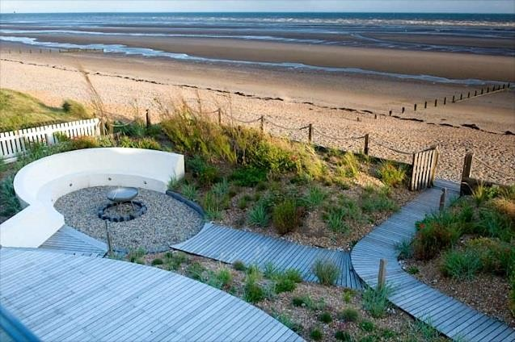
Plants from Palmstead grace a number of successful coastal gardens including some award winning designs:

Photo M. Harpur

Sea Gem at Camber Sands by Jo Thompson MSGD – SGD Planting Award 2013

And HTA Landscape’s work with Noel Kingsbury at Bexhill Seafront 2011 Winner 2012 Street Design Awards
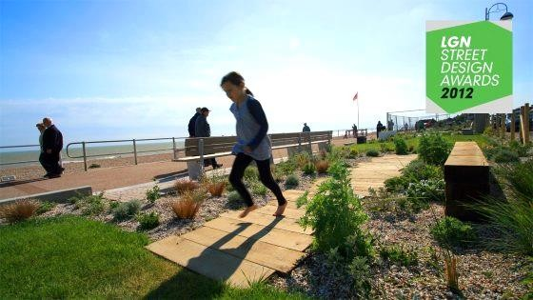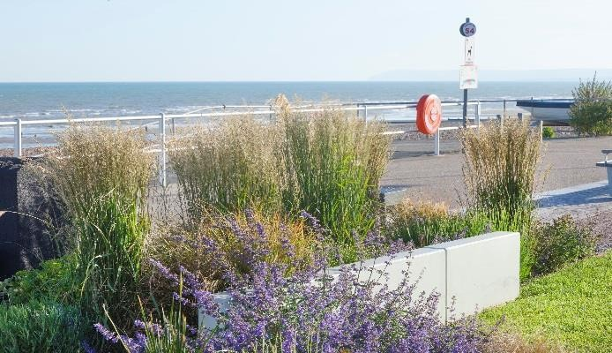
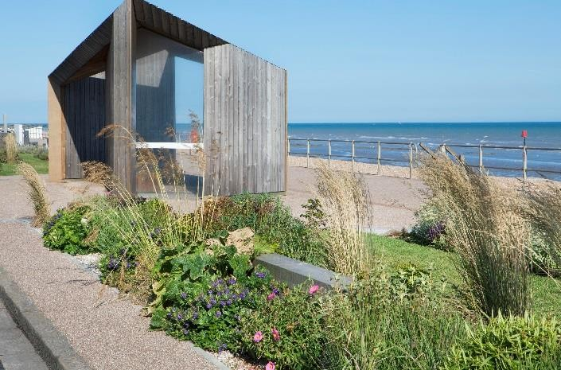
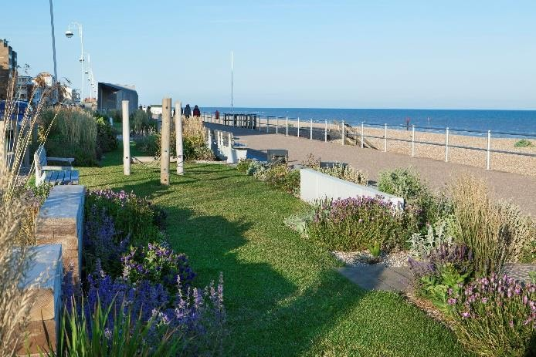

Photos HTA Landscape

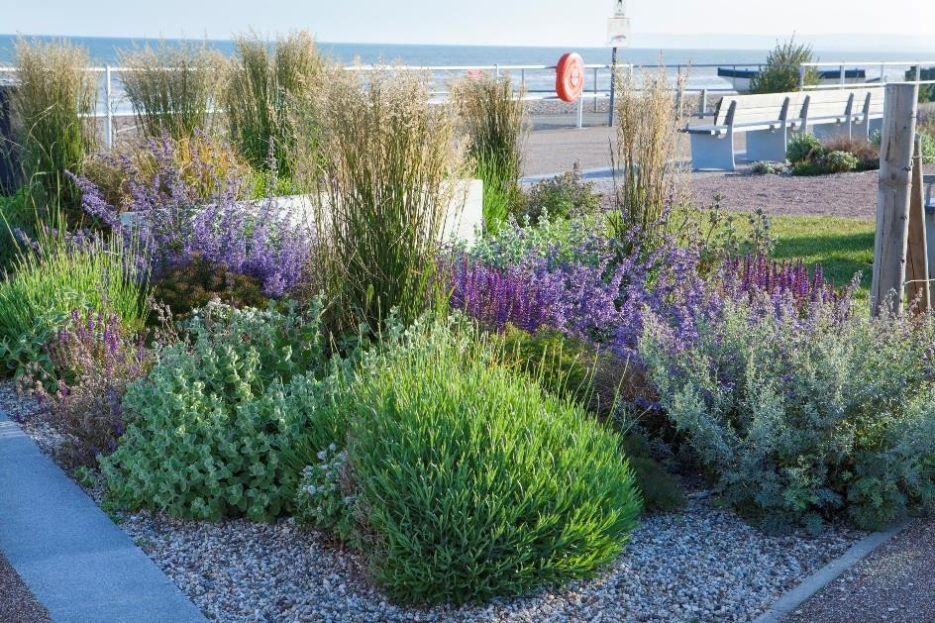
The sales team at Palmstead will be happy to assist your plant purchasing for coastal gardens, if you require additional guidance. Or order from our live availability on line at www.palmstead.co.uk

Tel: 01233 813340
Email: sales@palmstead.co.uk
Harville Road, Wye, Ashford Kent TN25 5EU

